ISLAMIC UNIVERSITY OF TECHNOLOGY
Organization of Islamic Cooperation
Board Bazar, Gazipur

Laboratory Report
CSE 4512

Title: Configuring numbered standard ACL in Cisco Devices
Objective:
- Plan an ACL Implementation
- Configure, Apply, and Verify a Standard ACL
Devices/Software Used: Cisco Packet Tracer
Diagram of the experiment(s):
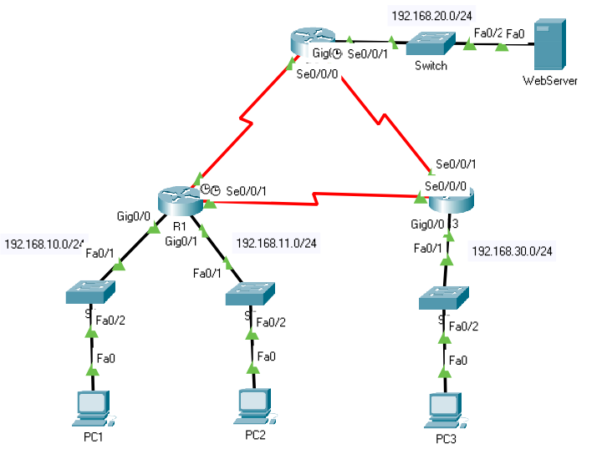

Working Procedure:
- Verified that the network has full connectivity.
PC1 to PC2:
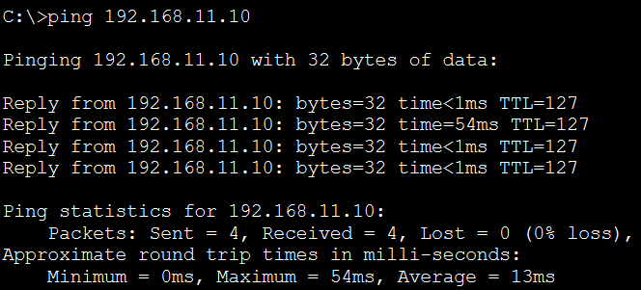
PC1 to PC3:
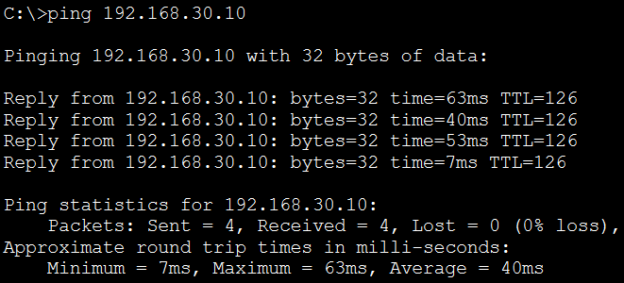
PC1 to WebServer:
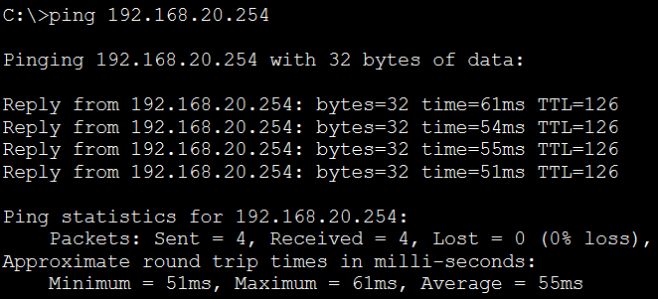

- Evaluated and planned ACL implementations.
- Configured and applied an ACL on R2.
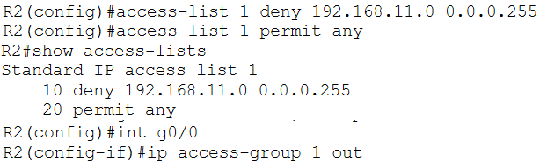
- Configured and applied an ACL on R3.
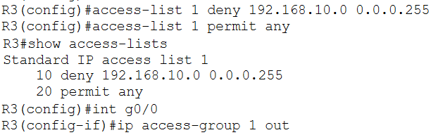
- Verified ACL configuration and functionality.
On R2:
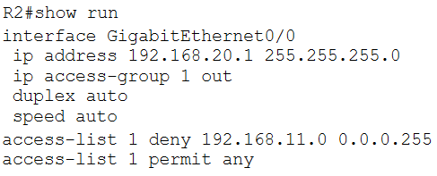
On R3:
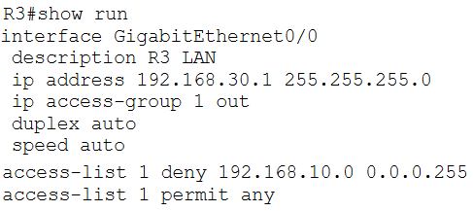
From PC1 to PC2:
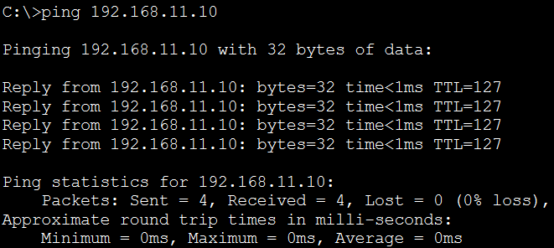
From PC1 to WebServer:
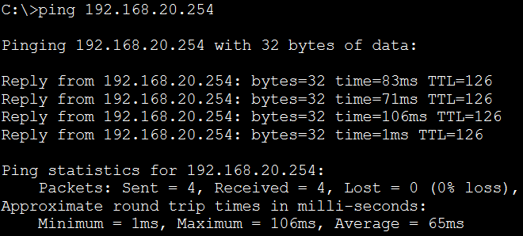
From PC2 to WebServer:
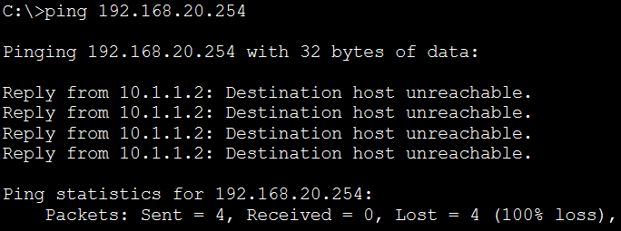
From PC1 to PC3:
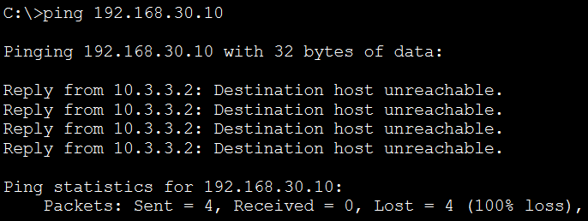
From PC2 to PC3:
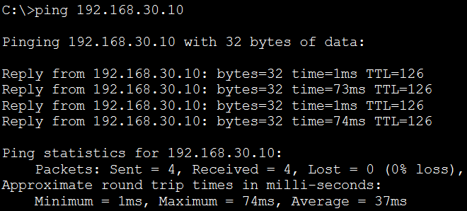
From PC3 to WebServer:
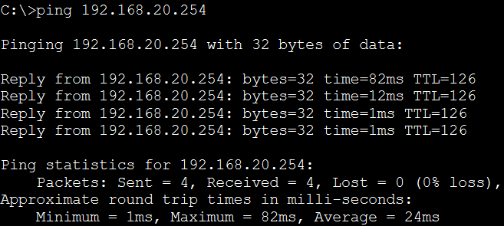
- Issued the show access-lists commands again.
R2:
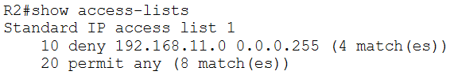
R3:
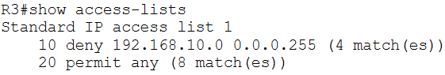

Questions:
Task # 01:
Question: The ping from 192.168.10.10 to 192.168.11.10 is successful or not?
Answer: Successful
Question: The ping from 192.168.10.10 to 192.168.20.254 is successful or not?
Answer: Successful
Question: The ping from 192.168.11.10 to 192.168.20.254 failed or not?
Answer: Failed

